

Lab #8 Tic Tac Toe Game
Artificial Intelligence
SUBMITTED BY:
UBAID AHMAD
ROLL NO:
2410-0011
SUBMITTED TO:
Ma’am Wardah Asad
DATE:
12/04/2026

TasK 1 Minimax Algorithm
Code:
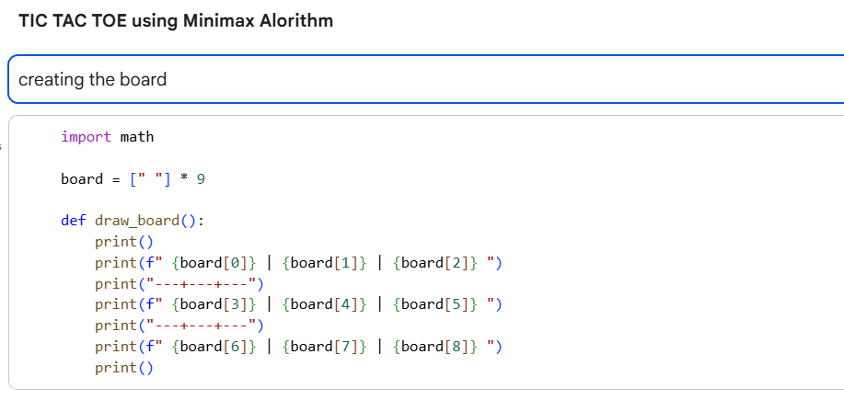

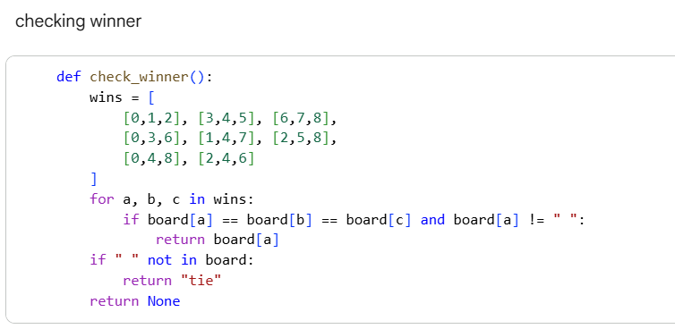

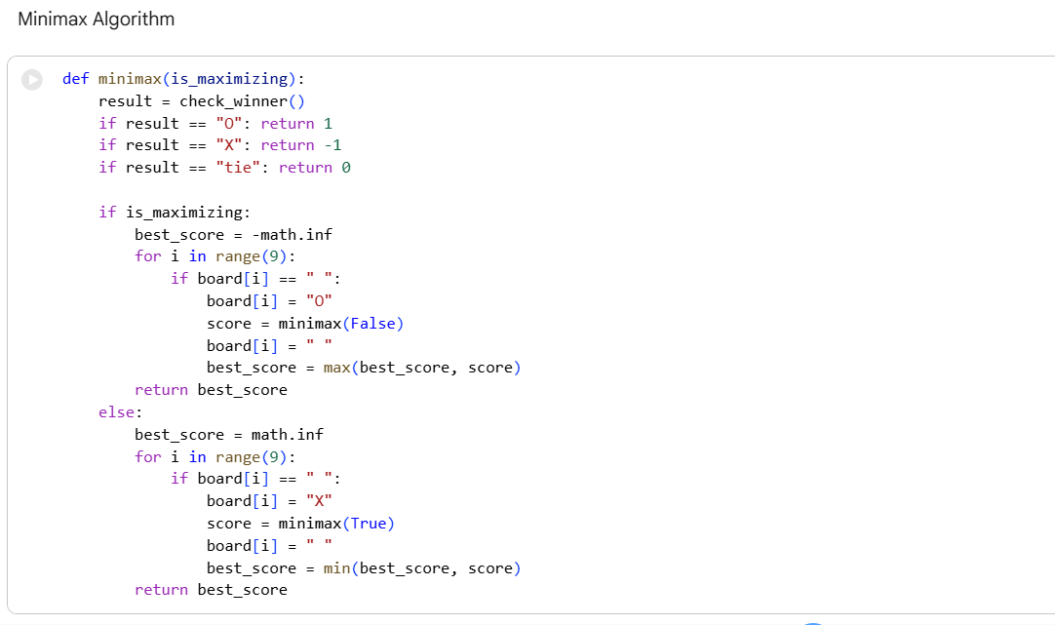
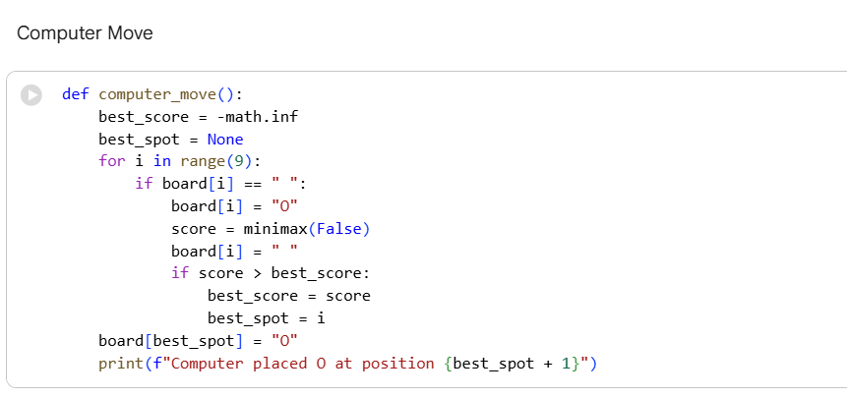

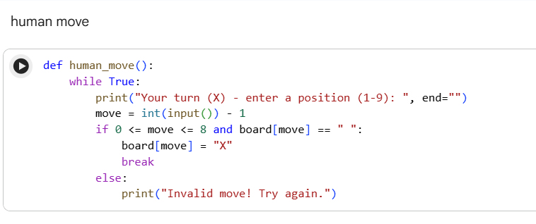
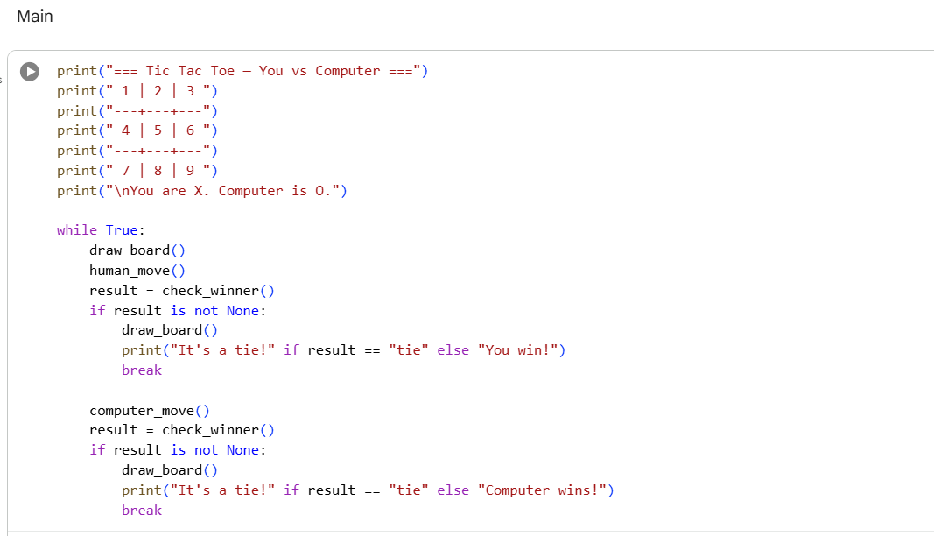
Playing the game:

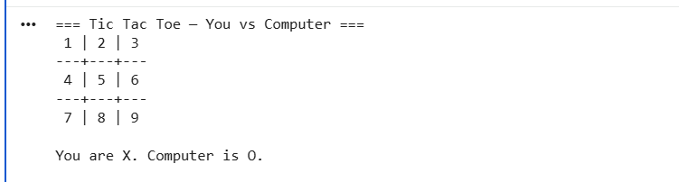
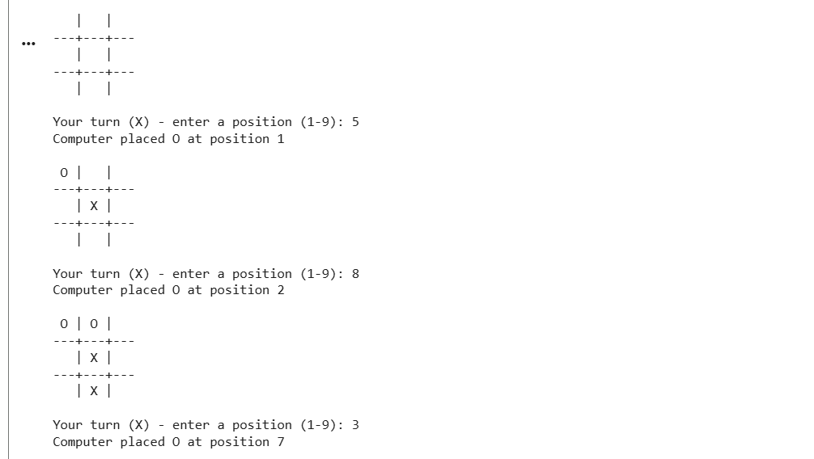
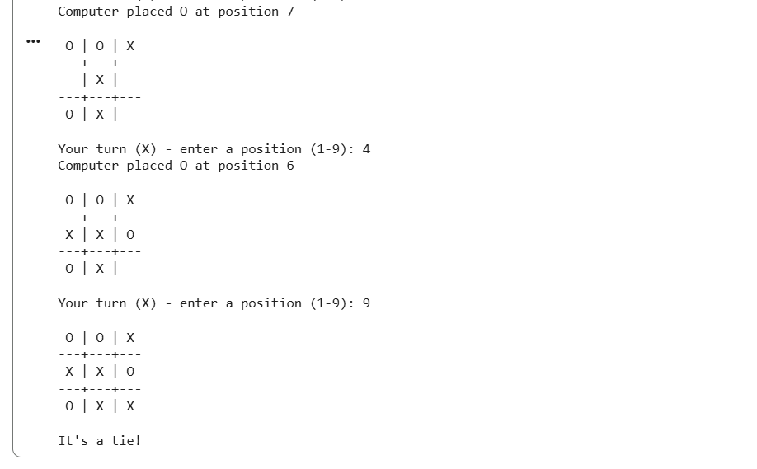
How minimax Works
- The computer tries every empty cell one by one
- For each cell it asks "what happens if I play here?"
- Then it imagines the human's best possible reply
- Then its own best reply to that, and so on...
- This keeps going until the game ends
- When the game ends it gives a score — +1 win, -1 lose, 0 tie
- These scores bubble back up to the original move
- The computer picks the move with the highest score
- The human is always assumed to play the worst move for the computer
- This way the computer is never caught off guard

Task 2 Alpa Beta pruning Algoritm
Code:
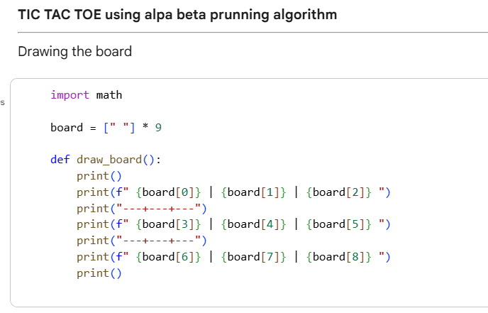
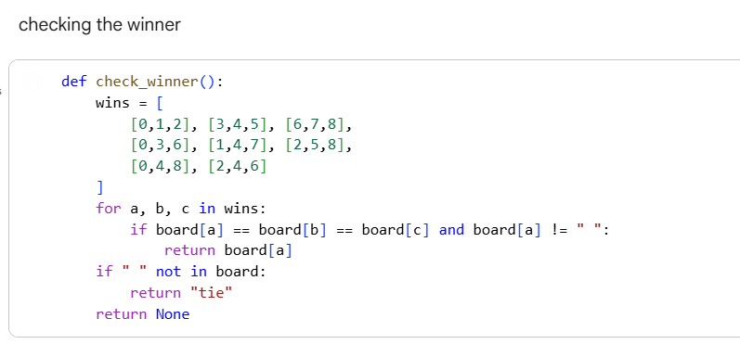
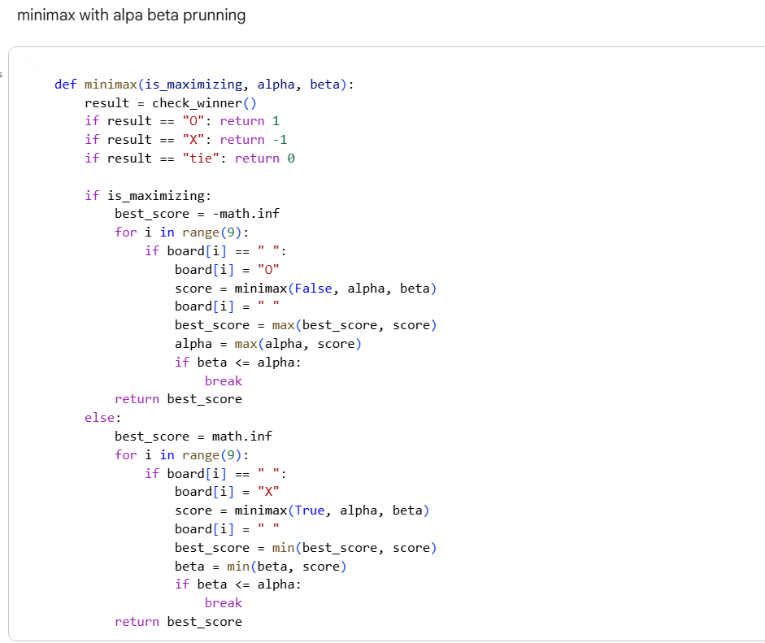
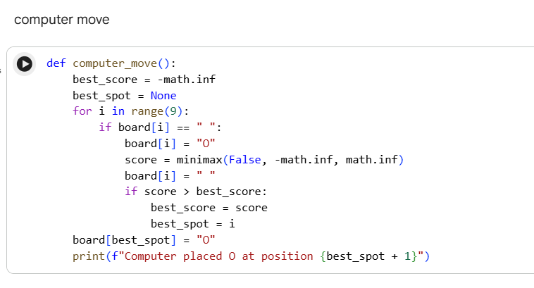
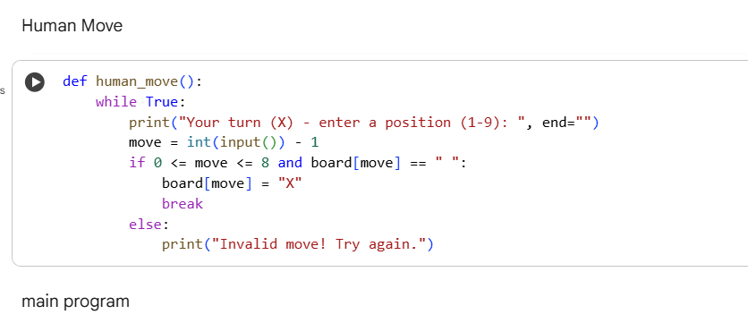
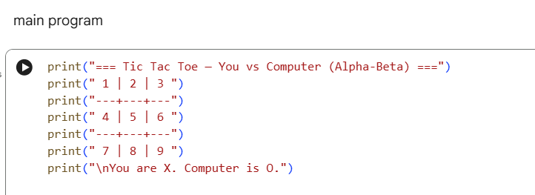
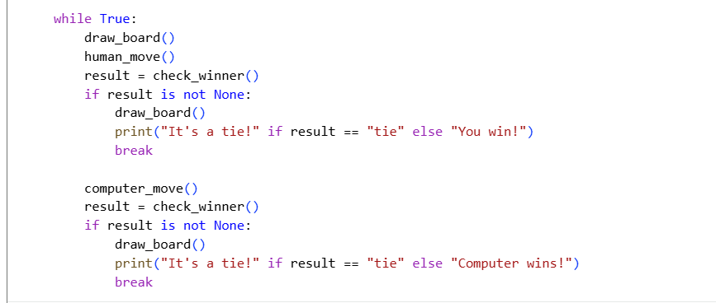
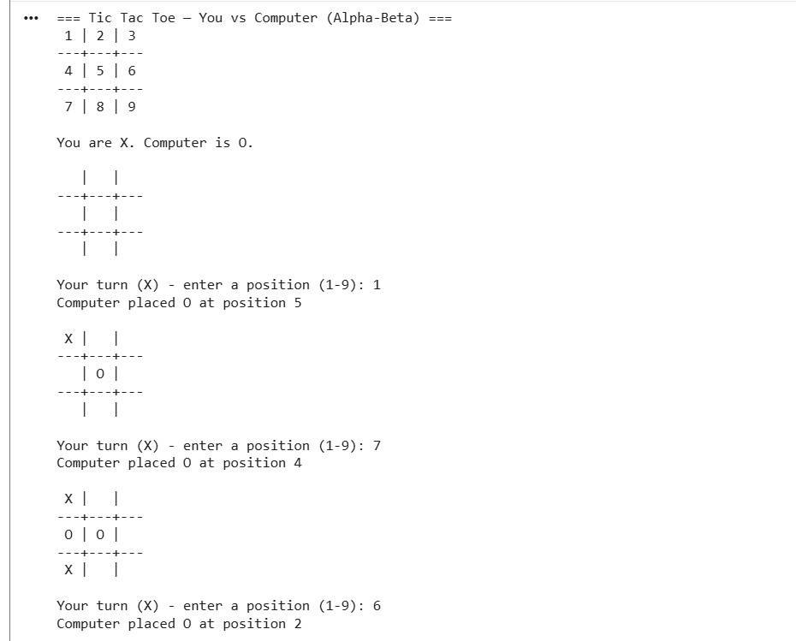
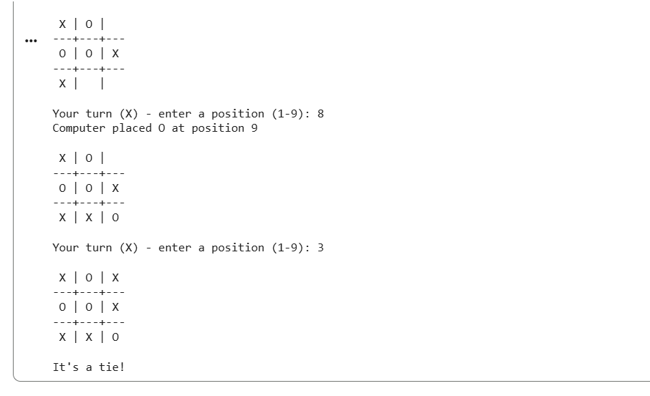

HOW DOES ALPA BETA PRUNNING WORK:
- While searching, the computer keeps track of the best score it already found
- If a branch can never beat that score, it just skips it
- Same result as plain minimax, just faster

